SMART DOOR LOCK SYSTEM

By Srivatsa Raju S (1BY18SCS13)

ABSTRACT DOCUMENT

Introduction

smart wireless door lock that can be unlocked by your smartphone.

Using smartphones and smart devices it becomes easier and affordable for all people and it’s a good option for us to make our daily life smarter.

Each day, new security systems and tools that you can make smarter environment by using them and create new ways to make your life safer and easier. you have seen smart locks for doors that have a keypad or use a fingerprint to set the door lock or unlock.

In this project, we want to make an Arduino based system that helps them to make a login section for a door by Wi-Fi and solenoid lock.

We don’t use keypad or complicated mechanical elements which is expensive and these are advantages of this system. We just stick a QR code to the door and the allowed people can scan it to see the login page and enter their password. After typing the correct password, the solenoid lock will be activated and the door will be unlocked.

Data Flow Diagram

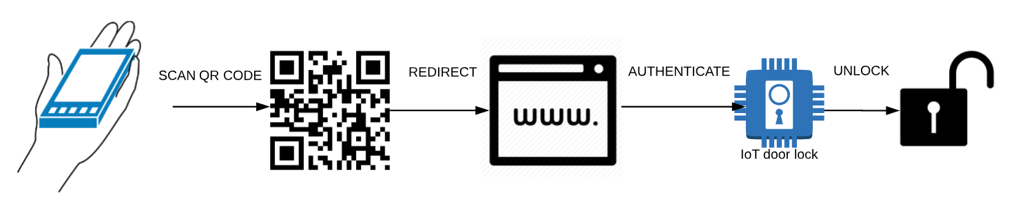

Connection Diagram

Arduino Uno R3

ESP8266 Wi-Fi

Solenoid Lock

Hardware Requirements

Arduino Uno R3 – 1 – ₹ 345

ESP8266 Wi-Fi Module - 1 ₹ 305

Solenoid lock 12V – 1 ₹ 500

TIP120 Power Darlington Transistors – 1 ₹ 25

IRFZ44N N-Channel MOSFET Transistor – 1 ₹ 50

1K Ohm Resistor - 1 ₹ 2

100k Ohm Resistor – 1 ₹ 3

1n4001 diode – 1 ₹ 20

Software requirements

Arduino IDE

Web Browser - HTML CSS

QR code Generator

Cost Estimation

Total Hardware cost (Approx.) - ₹ 1250